**~~ACNet-based MobileNet for image classification~~**

# Abstract

~~In this paper, we propose a novel ACNet-based~~ ~~MobileNet(Adaptively Connected Neural Networks based MobileNet) for image classification. Google's MobileNet[1] gets a significant achievement in image classification on the mobile device platform in recent years.~~ ~~However, MobileNet has fewer model parameters, making its accuracy still not comparable to other large-scale network models. Previously,~~ ~~ACNet[2] proposed to improve the traditional convolutional neural networks (CNNs), can flexibly change the global and local reasoning in the internal feature performance, and it also enhances classification accuracy. We believe that ACNet can adequately compensate for the above-mentioned MobileNet problems. Therefore, our ACNet – based MobileNet has benefited is that while retaining the inverted residual architecture of the MobileNet model, the model parameters are small enough. It also could improve the accuracy of image classification slightly. The code is available at~~ *~~https://github.com/TOMMYWHY/acnet_mobilenetv3~~*

# Introduction

Google's MobileNet significantly reduces the parameters of the model by using depthwise separable convolutions(DWS)[3], which makes a meaningful contribution to porting to mobile devices. Even though mobileNetV3 has been improved by 3.2% in accuracy compared with the mobileNetV2[4] in ImageNet classification through the inverted residual with linear bottleneck and squeeze and excitation structure, the accuracy is still not comparable to other large-scale network models, such as ResNet[5] and VGG[6]. How to improve the accuracy of MobileNet under the premise that the model volume is small enough has become the key to the successful application of deep learning in the field of mobile devices.

Simultaneously, more and more models use the Convolutional neural network (CNN) as a vital part of the model with the large-scale application of deep learning in image classification and target detection. However, the limitations of CNN itself have also been continuously confirmed. Due to CNN only extracts information from local neighboring pixels, each layer in the convolutional network does not have an excellent global overturning ability. Therefore, the convolution operation cannot distinguish two similar objects well. ACNet - Adaptively Connected Neural Networks can effectively solve this problem. The author holds that the optimization and reconstruction of DWS in MobileNet by ACNet can effectively avoid CNN pays too much attention to the local reasoning phenomenon, to improve the accuracy. Wang et al. also proposed that using ACNet has the function of reducing the model training cycle. The training period of ACNet-based MobileNet after optimization in this article will raise more efficiency compared to MobileNetV3[1].

1. 图片分类技术日趋成熟，可应用领域广发。很多模型对图片分类可以达到很高的准去率。这归功于传统卷积广泛应用。

经典轻量级模型也为图像分类在实际生活中的一广泛应用。

然而, 经典网络参数过大，进停留于试验阶段。很难应用到实际生活中。经典轻量级模型可以有效的嵌入移动设备，但准确率不高。

如何提高轻量级模型准确率，使得深度学习更好的应用到实际生活生产中，十分关键。

1. Cnn 与 mlp结合出很多优秀模型，但他们具有局限性。 Acnet 可以 结合cnn 与mlp。确保信息的完整性。

# 本文中经过优化的基于ACNet的思想架构对 现有经典移动端模型MobileNet 和 ghostNet 进行改进与优化，从而获得更高的准确率。

# Background and Literature review

Since LeCun's[7] paper on CNN was published, CNN's modern structure has been widely used in image classification. At the same time, large-scale datasets and the continuous improvement of computer computing power, deep CNN is continuously applied to image classification. The most famous is that Krizhevsky[8] proposed a prominent AlexNet CNN structure, and gained a significant breakthrough in image recognition. AlexNet was a great success, setting off a research boom in convolutional neural networks. After this, the researchers put forward other improvement techniques. Based on the AlexNet model, a more layered and deeper VGGNet[6] model was proposed to solve image classification and achieve higher accuracy. GoogLeNet[9] adopts the idea of an Inception structure to enrich models' diversity. ResNet[5] took the lead in proposing the concept of residual network, which effectively suppressed the overfitting of the model. During this period, CNN's model is continuously developing in a more complex and deeper direction. ResNet's score in the ILSVRC 2015[10] competition is more than 20 times that of AlexNet and more than eight times that of VGGNet. By increasing the depth, the network can obtain a more accurate non-linear objective function, so that the model can better reflect the characteristics. However, increasing the network's overall complexity makes the model too large, only staying in the laboratory stage.

For this reason, how to apply deep learning models to real-life has attracted more and more attention. The Google team has made many contributions to this. The Google team has proposed MnasNet[8] and MobileNet. Among them, MobileNet uses technologies such as an inverted residual network and DWS to reduce the model parameters significantly. Although the model can be applied to mobile devices, the reduced model parameters also bring a side effect of decreasing accuracy. Simultaneously, another defect of CNN is also reflected on MobileNet: CNN only extracts information from local neighboring pixels, so each layer inside the convolutional network does not have an excellent global knockdown capability[9]. Therefore, the convolution operation cannot distinguish two similar objects well. The ability to distinguish between two similar objects on a mobile device is another major bottleneck for deep learning applications.

This paper's primary purpose is to build a deep learning model with sufficiently small parameter models and sufficient accuracy. Aiming at the shortcomings of CNN, we use ACNet's flexible parameter storage method to learn the ability to transform general data local and global reasoning and propose an ACNet-based MobileNet network model. In this way, a brand-new, mobile-friendly, and high-precision image classification model is obtained.

# related work and Literature review

Cnn

Alex vgg googlenet

Resnet

Mobilenet 123

Shullf net

Ghostnet

Acnet

介绍 mobilenet 结构

介绍 ghostnet结构

介绍acnet

# Methodology

**Architecture**

Guangrun Wang proposed the ACNet mention formula 1 which uses the weights of β and γ to control CNN and MLP adaptively. It makes a specific layer of the model have both global inference and local inference. The formula also mentions a weight α, which is the weight that controls the transformation of itself. The three weight values are automatically updated by backpropagation to make it self-adaptive. It is easy to see from the formula that when the weight of α and γ is 0, the formula represents the traditional CNN. When the weights of α and β are 0, the formula represents an MLP operation. When the weight of β and γ is 0, the formula represents a 1*1 convolution operation.

Inspired by ACNet, author proposed formula 2 which contains two parts of global inference and self-transformation and is controlled by weights γ and α, respectively. When the formula 2 applied to the 1*1 convolution operation, it can change the dimension and at the same time has the ability of global inference.

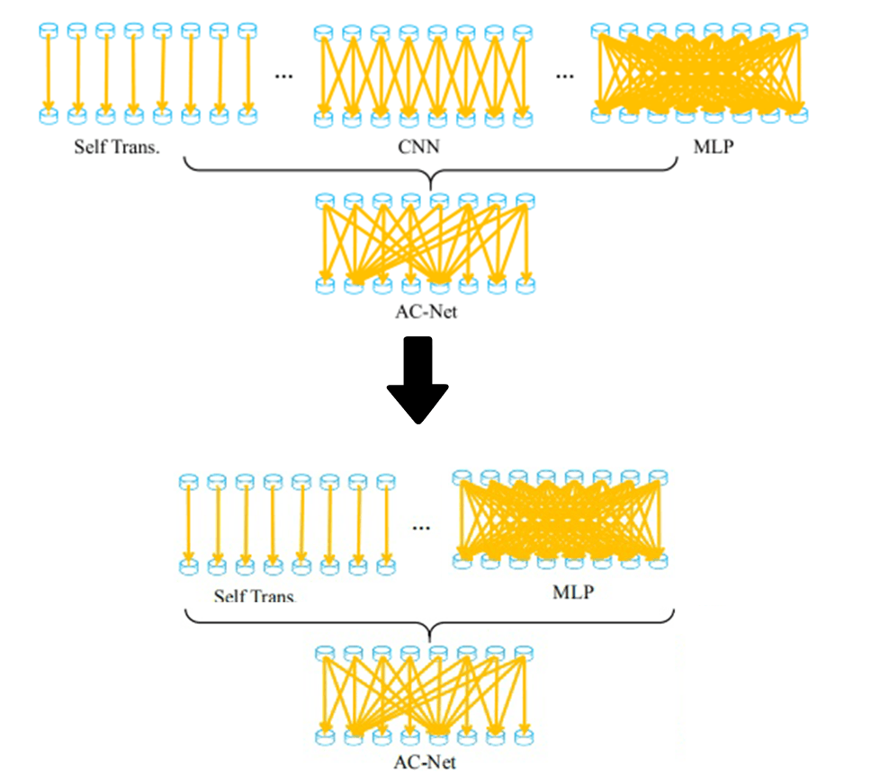

Figure 1: formula 2

**ACNet-based MobileNet**

By analyzing the network structure of MobileNet, the unique design method of the inverted residuals module is using a 1*1 convolution operation to change the dimension of inputs. The dimensional change will lose a large of the redundancy information. It is the most crucial reason why MobileNet is less accurate than other large networks. The ACNet-based MobileNet, which the author proposed, uses formula (2) to optimize the 1*1 convolution operation in the inverted residual module. It makes the inverted residual module have certain global inference ability. X is the input layer, ,​, represent the learnable weights. Use the global transformation or the self-transformation for self-inference through the two weight parameters of α,γ. Due to the adaptive updating weights via backpropagation, the convolution operation can preserve the part of image's redundancy information to the greatest extent by global inference parameters.

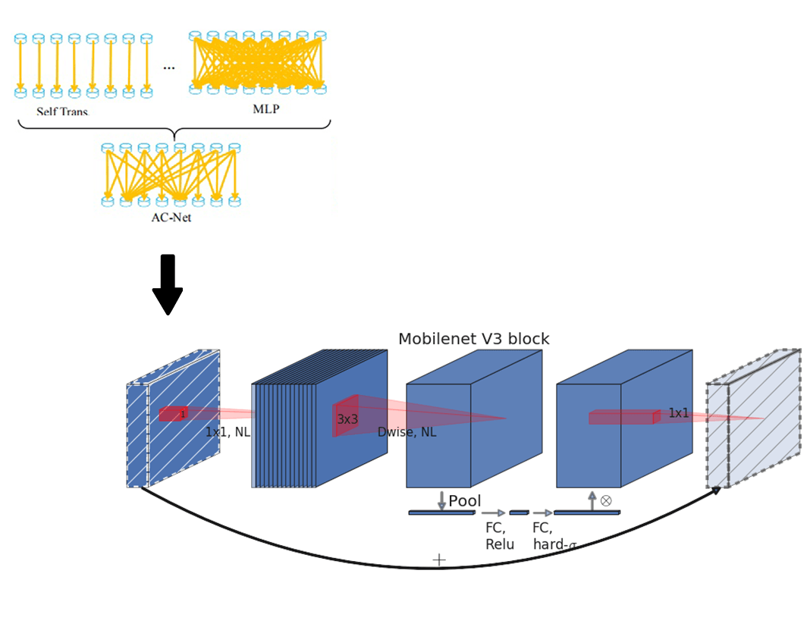

Figure1: the adaptive inverted residual module (AIR)

Mobilenetv3 uses the inverted residual with linear bottleneck module and the structure of squeeze and excitation. We propose an adaptive inverted residual module (AIR) with the same structure. In Figure 2 AIR is defined by a 1*1 Expansion layer followed by depth-wise convolutions and a 1*1 projection layer. MnasNet[11] built upon the MobileNetV2 structure by introducing lightweight attention modules based on squeeze and excitation into the bottleneck structure. The Expansion layer use its change deformation and global optimization.



Figure2: adaptive inverted residual module (AIR)

The author designed the model only to optimize the Expansion layer in AIR. The reason is that the author believes that the input dimension changed after into the Expansion layer, leading to some redundant information is filtered. However, redundant information still represents certain information. Using the formula (2) will add a global inference to a two-dimensional image in the Expansion layer to efficiently pass more input information to the Depthwise layer. The author did not optimize the Projection layer because the Projection layer's effect is only a restoration of the dimension to the same with input. Even with any variation of AcnNet Formula 1, the original input layer can not be recovered from the Depthwise layer extension. This is the reason the AIR module is only optimized for the Expansion layer.

**ACNet-based GhostNet**

Huawei team has recently proposed the GhostNet, an innovative lightweight model, in which it defines the term Ghost module. The module consists primarily of a cheap operation and a primary operation. The module consists primarily of a cheap operation and a primary operation. An analysis of Ghostnet’s paper here shows that the Linear transformations in question are equivalent to cheap operations. And the paper also mentions: the linear operations Φ operate on each channel whose computational cost is much less than the ordinary convolution. In practice, there could be several different linear operations in a Ghost module, e.g. 3 × 3 and 5 × 5 linear kernels, which will be analyzed in the experiment part.

Figure 3 is the Ghost module structure, which is divided into two operations to obtain the same number of characteristic graphs as ordinary convolution, namely Primary Operation and Cheap Operation. The paper mention that the whole Ghost module here needs to be stressed the same number of feature maps. Firstly, the input enters Primary Operation, which using a small amount of convolution. For example, suppose the regular operation uses 32 convolution cores. In that case, the Primary Operation uses 16 convolution cores here, which cuts the computation in half. The previous output is then continued with the Cheap Operation for the second step. The Cheap Operation uses Depth-wise convolution φ such as 3 * 3. It is the key that performs the GhostNet model more effective than MobileNet. At last, the Primary Operation and Cheap Operation are spliced together to obtain an output with the same number of channels as the input.

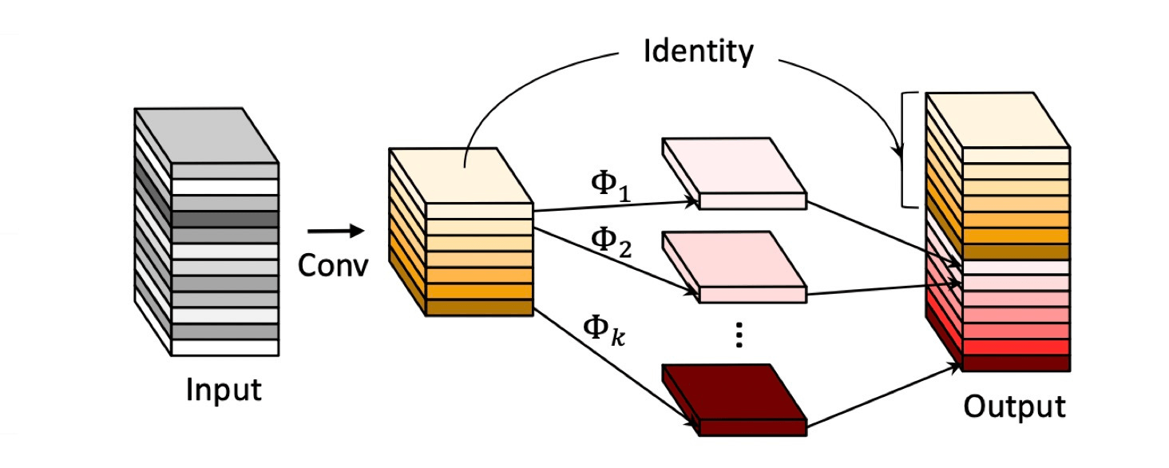

Figure3: Ghost module

The authors believe that the combination of global and local inference in Primary Operations to build an adaptive Ghost module. It not only can reduce the number of convolution but also improve the model's overall inference ability and further improve the model's accuracy. The reason is that when the input enters Primary Operation, it can carry both global and local inference information. It allows more essential information to pass through the Depth-wise convolutional of Cheap Operations. It makes the model has the resulting referential capability more plausible. The authors used the structure of Figure 4 on Operation Primary to introduce three factors: global inference, local inference, and self-transformation, which allowed the Ghost feature maps into the subsequent Cheap Operation to carry more helpful information and achieve the goal of improving accuracy.

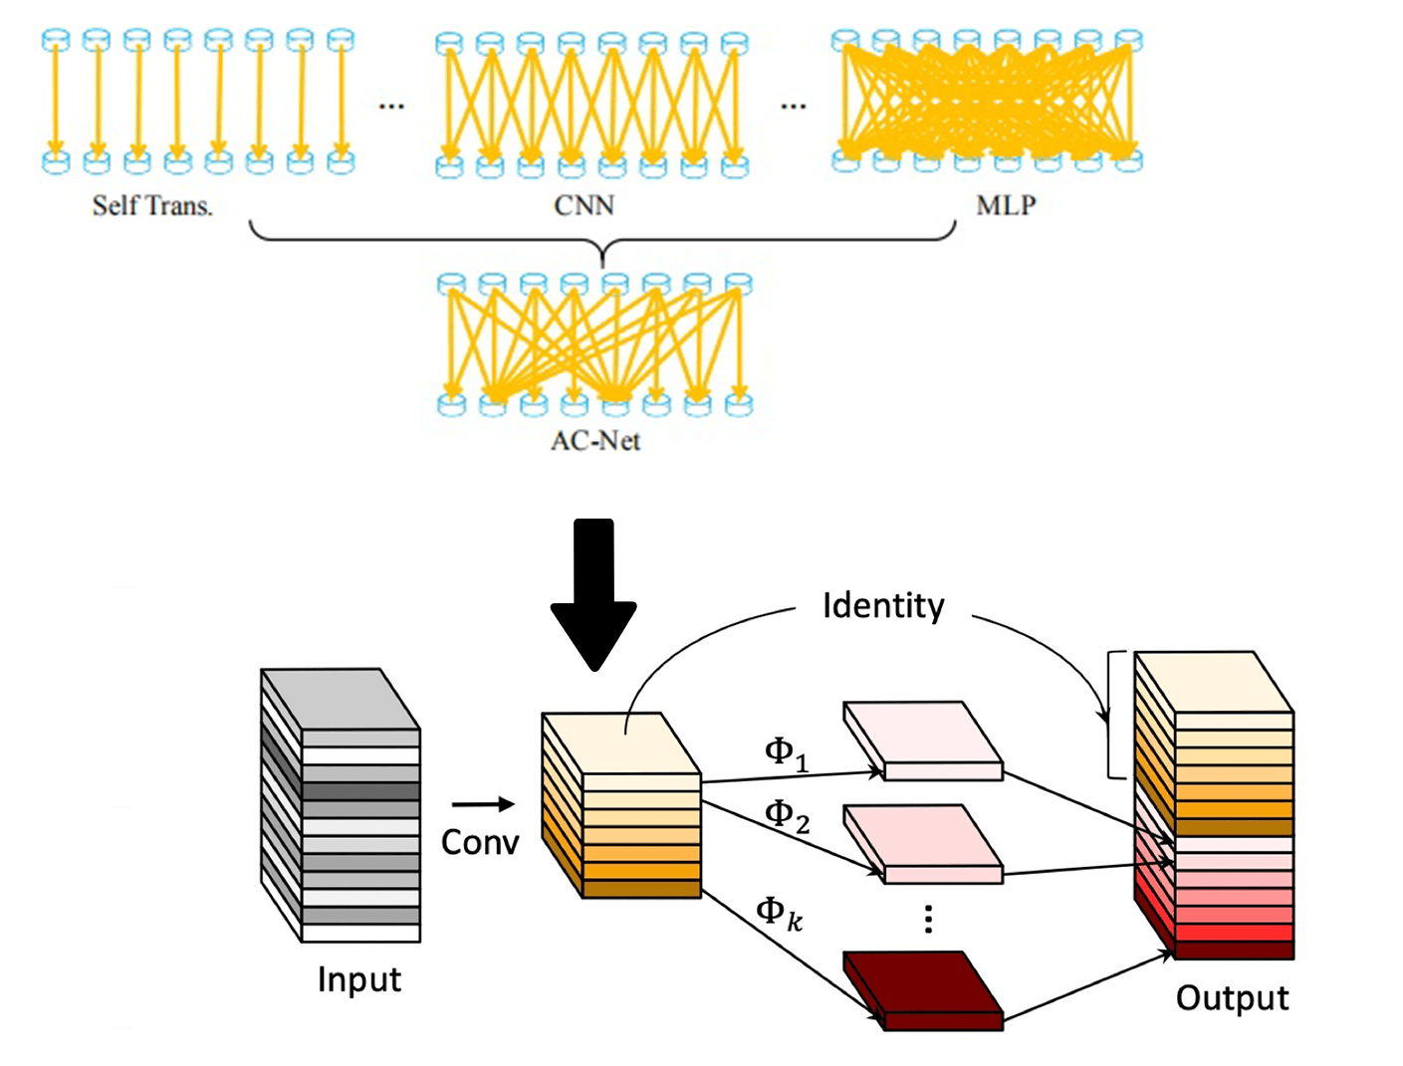

Figure4: the Adaptive Ghost module

The authors did not optimize the cheap operation because the input of the Cheap Operation is the output of the Primary Operation. At this point, the Cheap Operation input result already has the factors of global and local inference. The Cheap Operation does a regular Depth-wise convolutional convolution and then combines with the feature maps after Primary Operations. Therefore, in the Adaptive Ghost Module, AcNet Formula 1 only optimizes the part of primary operation. The results of the controlled experiment in the following paper can confirm the author’s point of view.

# Experiments

**Dataset**

This article uses Cifar-100[12] dataset. The dataset has 100 classes, and each class includes 600 images. Among the 60000 images, there are 50000 training images and 10000 testing images. The reason for using cifar100 as the data set this time is to verify that ACNet-based MobileNet has a certain global inference ability through more detailed classification. According to a convention, two error rates will be provided: top-1 and top-5. The top-5 error rate means that the testing image's correct label is not among the five most likely notes considered by the model. In the data preprocessing stage, the data pictures are uniformly cropped to a fixed size of 224*224 at the center point. We will mirror and flip the image randomly to achieve the purpose of expanding the dataset. ~~All the implementation details and experiment settings are the same as [13][14].~~

***ACNet-based MobileNet***

**Training**

Author use multiple controlled trials to test ACNet-based MobileNet. The first is to verify the validity of the ACNet-based MobileNet theory. Use the MobileNetV3-Small structure mentioned in the mobilenetv3 paper for training on cifar100. Then use ACNet-based MobileNet (Table1)with the same structure and params to classify and predict cifar100. Use a single factor to verify the functionality of ACNet-based MobileNet.

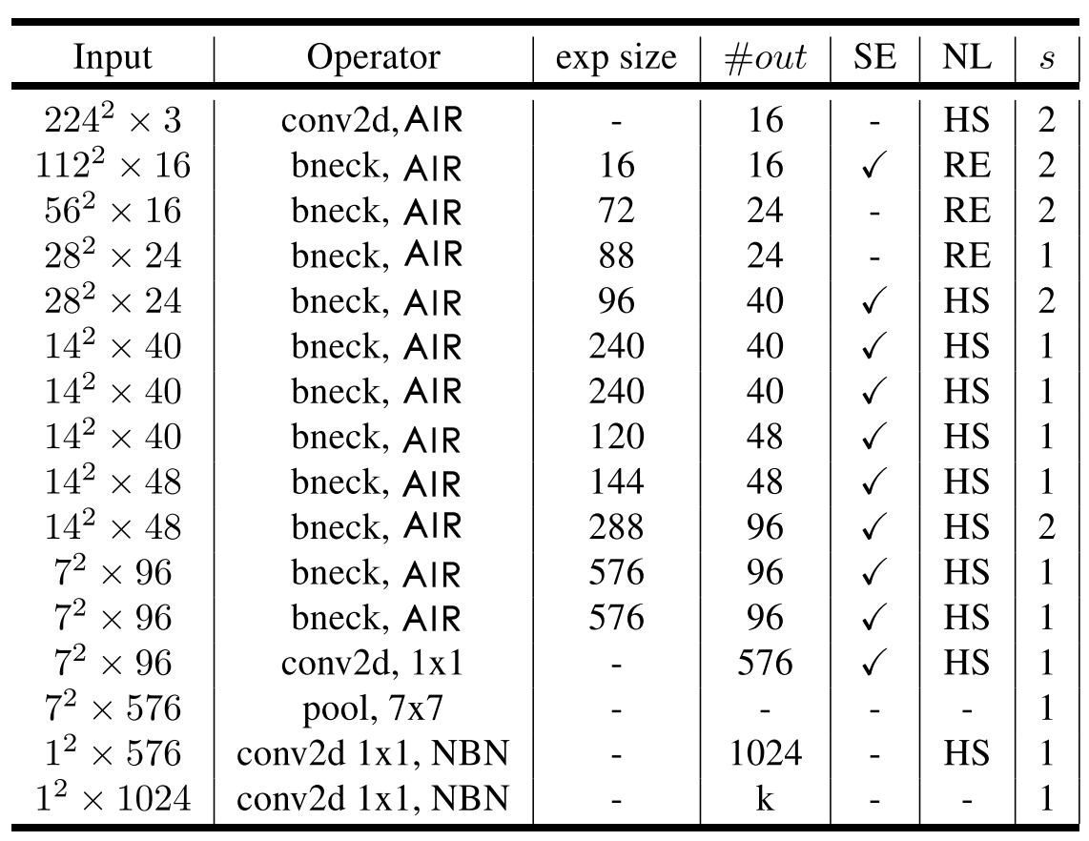

Table1: It uses the same architecture as mobilenetv3, which uses AIR instead of 3X3 and 5X5 convolution operations.

**﻿**

**Experiment results**

The table2 compares the accuracy of mobilennetv3 with that of ACNet-based MobileNet after the iteration of 100 epochs. The Author trained the models on a single RTX 2080 GPU with 10GB of memory. The maximum batch size of 128 is used, and the classification accuracy of Top-1 and Top-5 models was recorded. **CNet-based MobileNet** achieves the best top-1 and top-5 test set accuracy rates of 67.67% and 90.17%, respectively. The accuracy is 0.92% higher than what MobileNetV3(SMALL) had for Top-1. It is due to the use of AIR module to optimize the MobileNetV3. The model is adaptive with the global reasoning ability, which can adapt to more complex image separation problems and improve accuracy. It is in line with our above speculation.

|  |  |  |  |  |
| --- | --- | --- | --- | --- |
|  | Top-1 | Top-5 | Epoch | Training Time |
| MobileNetV3(SMALL) | 66.75 | 89.79 | 100 | 2h35min |
| ACNet-based MobileNet | **67.67** | **90.17** | 100 | 3h10min |

Table 2: ACNet-based MobileNet results

The AIR module has some side effects as well as improved accuracy. The training time of the whole model is prolonged because more parameters are introduced for global inference. The training time of ACNet-based MobileNet is longer than MobileNetV3 35 minutes running on a single GPU. However, the time complexity was still within an acceptable range. We can conclude from the Top-1 accuracy in figure 5 that ACNet-based MobileNet has a low accuracy rate in the beginning. The reason is that the large amount of complex redundant information to be processed in the global inference. However, with the increase of epochs, the models of MobileNetV3 and ACNet-based MobileNet converged at 31 and 32 iterations, respectively. The Top-5 accuracy of Figure 5 shows the trends of accuracy almost identical in ACNet-based MobileNet and MobileNetV3. The experiment shows that the AIR module introduces adaptive global inference, which leads the model parameters to increase, which leads to the long training time and the lag of convergence. However, the accuracy of the model and the training time depends on the setting of hyperparameters. In future test work, we will search for the super-parameters to get a better model.

Figure5: The Top-1 and Top-5 accuracy of **ACNet-based MobileNet VS** MobileNetV3

The authors also experimented with other variants of the formula (2). It includes using local inference and global inference, and self-transition and global inference. Moreover, It is clear from the data in table 3, variations of the AIR can still play a positive role in the precise classification. One of the most significant improvements AIR was mixed with an adaptive global inference in the Expansion layer. The authors concluded that the Expansion layer’s 1 * 1 operation filters a lot of important information. And the disadvantage of the inverted residuals module can be effectively mitigated by adding an adaptive global inference.

|  |  |  |  |
| --- | --- | --- | --- |
|  | Top-1 | Top-5 | **Epoch** |
| MobileNetV3(SMALL) | 66.75 | 89.79 | 100 |
| ACNet-based MobileNet(self+local) | 67.27 | 89.45 | 100 |
| **ACNet-based MobileNet(self+global)** | **67.67** | **90.17** | 100 |
| ~~ACNet-based MobileNet(local+global)~~ | ~~66.91~~ | ~~88.83~~ | ~~100~~ |
| ACNet-based MobileNet(local+global+self) | 67.63 | 88.57 | 100 |

Table 3: variants of the formula(2) AIR working in Expansion layer

***ACNet-based ghostnet***

**Training**

Acnet-based GhostNet used the same experimental environment as above. We were using Cifar-100 as the dataset. Furthermore, the data is preprocessed in the same as before. The training model uses the maximum 128batch size and iterates 100 times. As shown in table 4, GhostNet network structure is similar to the MobileNet, and uses the SE structure. The following table, where # EXP represents the number of first G-Module output characteristic graphs of G-bneck. Using the Adaptive Ghost Module to optimize the primary operation of G-bneck, the ACNet-based GhostNet model is obtained.

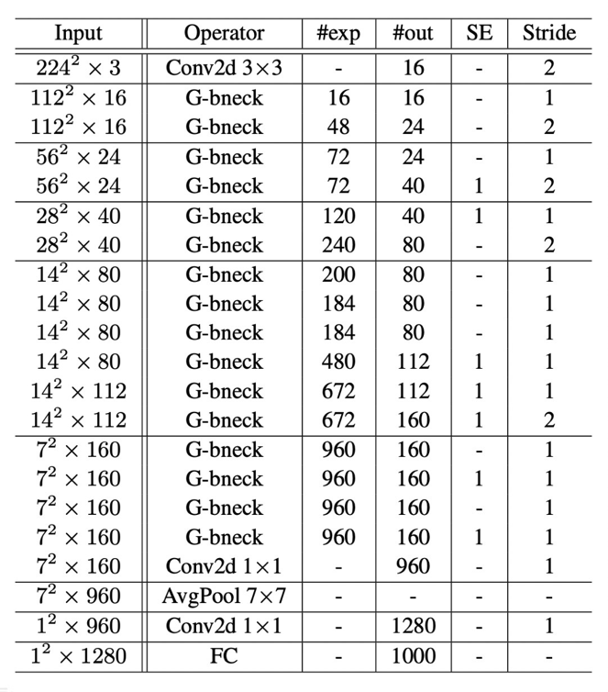

Table4: It uses the same architecture as GhostNet, which uses Adaptive Ghost module

**Experiment results**

The table5 compares the accuracy of GhostNet with that of ACNet-based MobileNet after the iteration of 100 epochs. ***ACNet-based ghostnet*** achieves the best top-1 and top-5 test set accuracy rates of **69.18**% and **90.89**%, respectively. There is 0.69% more than Ghostnet’s Top-1 accuracy rate. Although the ACNet-based GhostNet performance of classification was not perfect, the slight improvement in accuracy was consistent with the author’s previous predictions. From the results of the experiment, the adaptive ghost module is used to optimize the G-bneck, which makes the model adaptive with a certain global inference ability to adapt to more complex image separation problems and improve accuracy.

|  |  |  |  |  |
| --- | --- | --- | --- | --- |
|  | Top-1 | Top-5 | Epoch | Training Time |
| GhostNet | 68.49 | 90.83 | 100 | 4h0min |
| ACNet-based GhostNet | **69.18** | **90.89** | 100 | 5h20min |

Table 5: ACNet-based GhostNet results

As can be seen from Figure 6 below, the Adaptive Ghost Module has a limited effect on ACNet-based GhostNet classification accuracy. ACNet-based GhostNet and GhostNet converged after 39 and 36 iterations, respectively. The adaptive Ghost module brings limited optimization effect to The model and considerable time complexity. The reason is that ACNet-based GhostNet introduces three factors using Formula 1: self-transition, local inference, and global inference. To compare with the AIR of ACNet-based MobileNet, The Adaptive Ghost Module have more computation and parameters. It is also why ACNet-based GhostNet requires more time for training.

Figure6: The Top-1 and Top-5 accuracy of ACNet-based ***ghostnet*** VS ***ghostnet***

Table 6 lists different variants of the Adaptive Ghost Module, and the author experiments the models with different combinations of factors. The most accurate classification model is still an adaptive model with three factors. The author hypothesizes that three adaptive factors preserve the redundant information to the greatest extent and make the feature maps after the primary operations have the most favourable information. The author will carry on the further experimental demonstration in this direction in the follow-up work.

|  |  |  |  |
| --- | --- | --- | --- |
|  | Top-1 | Top-5 | **Epoch** |
| GhostNet | 68.49 | 90.83 | 100 |
| acnet_ghost (self+global) | 67.58 | 89.90 | 100 |
| acnet_ghost (self+local) | 67.27 | 89.24 | 100 |
| acnet_ghost (local+global) |  |  | ~~100~~ |
| **ghost (local+global+self)** | **69.18** | **90.89** | 100 |

Table 6: variants of the adaptive Ghost module working in primary operation

# conclusions

The ACNet-based MobileNet model uses the AIR module, which in theory can effectively improve the global reasoning ability and retain more information in the inverted residual module. However, it has not been significantly confirmed in this experiment. Try to use the ACNet-based MobileNet model to distinguish objects with the same shape characteristics effectively, and then get a more accurate model. From the experimental results, the effect is not significant. The reason may be the hyperparameter learning rate is set too small, and follow-up work will conduct search experiments on the learning rate to obtain a better performing model. In the next work, other different data sets will be used to verify the model to ensure the rigor of the conclusion.

The results of the experiment did not meet expectations. However, we still got a conclusion that the method of adaptively adjusting MLP and CNN cannot solve the information loss caused by the dimensional changes in the inverted residual module. The author speculates that the reason is the inverted residual module is reduced to the loss of two-dimensional information, which cannot be compensated by simple global inference. In the follow-up work, a lot of experiments and explorations will be carried out to find an innovative inverted residual module that retains most of the information as much as possible. In this way, image classification technology can be better applied to the mobile terminal, and deep learning related technology can be better applied to life.

# Inferences

[1] A. Howard *et al.*, “Searching for mobileNetV3,” *Proc. IEEE Int. Conf. Comput. Vis.*, vol. 2019-Octob, pp. 1314–1324, 2019, doi: 10.1109/ICCV.2019.00140.

[2] G. Wang, K. Wang, and L. Lin, “Adaptively connected neural networks,” *Proc. IEEE Comput. Soc. Conf. Comput. Vis. Pattern Recognit.*, vol. 2019-June, pp. 1781–1790, 2019, doi: 10.1109/CVPR.2019.00188.

[3] A. G. Howard and W. Wang, “MobileNets: Efficient Convolutional Neural Networks for Mobile Vision Applications,” 2012.

[4] M. Sandler, A. Howard, M. Zhu, A. Zhmoginov, and L. C. Chen, “MobileNetV2: Inverted Residuals and Linear Bottlenecks,” *Proc. IEEE Comput. Soc. Conf. Comput. Vis. Pattern Recognit.*, pp. 4510–4520, 2018, doi: 10.1109/CVPR.2018.00474.

[5] K. He, X. Zhang, S. Ren, and J. Sun, “Deep residual learning for image recognition,” *Proc. IEEE Comput. Soc. Conf. Comput. Vis. Pattern Recognit.*, vol. 2016-Decem, pp. 770–778, 2016, doi: 10.1109/CVPR.2016.90.

[6] K. Simonyan and A. Zisserman, “Very deep convolutional networks for large-scale image recognition,” *3rd Int. Conf. Learn. Represent. ICLR 2015 - Conf. Track Proc.*, pp. 1–14, 2015.

[7] Y. LeCun, L. Bottou, Y. Bengio, and P. Haffner, “Gradient-based learning applied to document recognition,” *Proc. IEEE*, vol. 86, no. 11, 1998, doi: 10.1109/5.726791.

[8] A. Krizhevsky, I. Sutskever, and G. E. Hinton, “ImageNet classification with deep convolutional neural networks,” *Commun. ACM*, vol. 60, no. 6, pp. 84–90, 2017, doi: 10.1145/3065386.

[9] C. Szegedy *et al.*, “Going deeper with convolutions,” in *Proceedings of the IEEE Computer Society Conference on Computer Vision and Pattern Recognition*, 2015, vol. 07-12-June-2015, doi: 10.1109/CVPR.2015.7298594.

[10] O. Russakovsky *et al.*, “ImageNet Large Scale Visual Recognition Challenge,” *Int. J. Comput. Vis.*, vol. 115, no. 3, pp. 211–252, 2015, doi: 10.1007/s11263-015-0816-y.

[11] M. Tan *et al.*, “Mnasnet: Platform-aware neural architecture search for mobile,” *Proc. IEEE Comput. Soc. Conf. Comput. Vis. Pattern Recognit.*, vol. 2019-June, pp. 2815–2823, 2019, doi: 10.1109/CVPR.2019.00293.

[12] M. B. McCrary, “Urban multicultural trauma patients.,” *ASHA*, vol. 34, no. 4, 1992.

[13] G. Wang, P. Luo, and X. Wang, “Batch Kalman Normalization: Towards Training Deep Neural Networks with Micro-Batches.”

[14] G. Wang, J. Peng, P. Luo, X. Wang, and L. Lin, “Kalman normalization: Normalizing internal representations across network layers,” *Adv. Neural Inf. Process. Syst.*, vol. 2018-December, no. NeurIPS, pp. 21–31, 2018.

[15] T. He, Z. Zhang, H. Zhang, Z. Zhang, J. Xie, and M. Li, “Bag of tricks for image classification with convolutional neural networks,” *Proc. IEEE Comput. Soc. Conf. Comput. Vis. Pattern Recognit.*, vol. 2019-June, pp. 558–567, 2019, doi: 10.1109/CVPR.2019.00065.